MyMovies(OTT Platform)
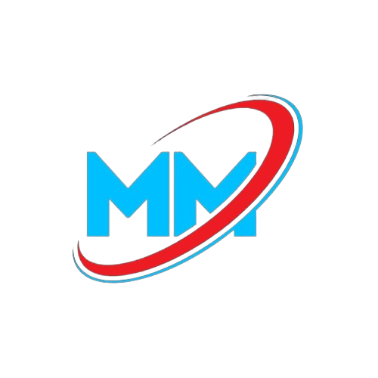
Software Requirements Specification

Date- 16/04/2024

Sourabh Gurwani
(12218647)



Prepared for
Continuous Assessment 3
Spring 2024

Revision History

Date | Description | Author | Comments
<date> | <Version 1> | <Your Name> | <First Revision>

Table of Contents

Revision History ii
CLIENT Approval ii
1. Introduction 1
1.1 Purpose 1
1.2 Scope 1
1.3 Definitions, Acronyms, and Abbreviations 1
1.4 References 1
1.5 Overview 1
2. General Description 2
2.1 Product Perspective 2
2.2 Product Functions 2
2.3 User Characteristics 2
2.4 General Constraints 2
2.5 Assumptions and Dependencies 2
3. Specific Requirements 2
3.1 External Interface Requirements 3
3.1.1 User Interfaces 3
3.1.2 Hardware Interfaces 3
3.1.3 Software Interfaces 3
3.1.4 Communications Interfaces 3
3.2 Functional Requirements 3
3.2.1 <Functional Requirement or Feature #1> 3
3.2.2 <Functional Requirement or Feature #2> 3
3.5 Non-Functional Requirements 4
3.5.1 Performance 4
3.5.2 Reliability 4
3.5.3 Availability 4
3.5.4 Security 4
3.5.5 Maintainability 4
3.5.6 Portability 4
3.7 Design Constraints 4
3.9 Other Requirements 4
4. Analysis Models 4
4.1 Data Flow Diagrams (DFD) 5
5. Github link…………………………………………………………………………………………………….5
5. CLIENT APPROVAL PROOF……………..…………………………………………………………………….5
A. Appendices 5
A.1 Appendix 1 5
A.2 Appendix 2 5

Introduction
1.1 Purpose
The purpose of this Software Requirements Specification (SRS) document is to define the requirements for the frontend of the MyMovies OTT platform. This document outlines the functionality and features that the platform will provide to its users, as well as the expected behavior and performance of the frontend built using HTML, CSS, JavaScript, Bootstrap, and Angular.

1.2 Scope
MyMovies is an Over-The-Top (OTT) streaming platform that provides users with access to a wide variety of movies and TV shows. This SRS covers the development and implementation of the frontend for the platform, including features such as user registration, content browsing, streaming, recommendations, user profiles, and other interactive functionalities. The frontend is designed to work seamlessly across different devices and browsers, ensuring a smooth and responsive user experience.

1.3 Definitions, Acronyms, and Abbreviations
OTT: Over-The-Top streaming, a media delivery method over the internet.
SRS: Software Requirements Specification, a document outlining the software's functionality and features.
UI: User Interface, the graphical interface that users interact with.
HTML: HyperText Markup Language, used to structure content on the web.
CSS: Cascading Style Sheets, used to style web content.
JS: JavaScript, a scripting language for interactive web content.
Bootstrap: A front-end framework for developing responsive and mobile-first websites.
Angular: A web application framework for building dynamic, single-page applications.

1.4 References
Design Guidelines: Reference design guidelines for user experience and interface design.
API Documentation: Refer to the documentation for APIs used in the project.
Frontend Framework Documentation: Reference documentation for Bootstrap and Angular frameworks.
Industry Standards: Refer to industry standards for web accessibility and responsive design.

1.5 Overview
MyMovies is an online streaming platform that offers a wide range of movies and TV shows to its users. The frontend is developed using modern web technologies such as HTML, CSS, JavaScript, Bootstrap, and Angular to create an engaging and responsive user experience.

Key features include:

User Registration and Authentication: Users can create accounts, log in securely, and manage their profiles.
Content Browsing and Search: Users can browse and search for content using various filters and categories.
Content Streaming: Users can stream high-quality video content in different resolutions.
Personalized Recommendations: The platform provides content recommendations based on user preferences and viewing history.
Watchlists and Playlists: Users can create and manage watchlists and playlists for easy access to their favorite content.
User Reviews and Ratings: Users can rate and review movies and TV shows.
The frontend is designed to be user-friendly and accessible across different devices, providing a seamless streaming experience for all users. The platform aims to deliver high performance and reliability while adhering to data privacy and security standards.

2.GENERAL DESCRIPTION

2.1 Product Perspective
MyMovies is an Over-The-Top (OTT) streaming platform that provides users with access to a diverse selection of movies and TV shows. The platform is a part of the broader entertainment industry, offering an alternative to traditional cable and satellite TV services. MyMovies integrates with various third-party services, such as content providers and payment gateways, to deliver a comprehensive streaming experience. The platform's frontend is built using HTML, CSS, JavaScript, Bootstrap, and Angular, providing a modern, responsive, and interactive user interface. It is designed to be compatible with different devices and browsers, allowing users to access content seamlessly.

2.2 Product Functions
The MyMovies OTT platform provides a variety of functions to its users, including:

User Authentication: Secure user registration and login, with password recovery options.
Content Discovery and Browsing: Users can browse and search for content using categories, genres, and search filters.
Content Streaming: Users can stream high-quality video content in different resolutions and formats.
User Profiles: Users can create and manage profiles, including preferences, viewing history, and watchlists.
Personalized Recommendations: The platform offers personalized content recommendations based on user preferences and viewing history.
Watchlists and Playlists: Users can create and manage watchlists and playlists for easy access to their favorite content.
User Reviews and Ratings: Users can rate and review content, helping others make informed decisions about what to watch.
Subscription Management: Users can manage their subscription plans, including upgrades, downgrades, and cancellations.
Notifications: Users receive notifications about new content, recommendations, and account-related information.
Social Sharing: Users can share content and engage with others through social media integration.

2.3 User Characteristics
The MyMovies platform caters to a diverse user base, including:

Casual Viewers: Users who watch content occasionally and may prefer a pay-per-view or free tier.
Subscribers: Users who have a monthly or annual subscription plan and access premium content.
Content Enthusiasts: Users who watch content frequently and may use advanced features such as custom playlists and watchlists.
Reviewers and Critics: Users who actively engage with content by providing reviews and ratings.
Multi-Device Users: Users who watch content across various devices and expect a consistent experience.

2.4 General Constraints
The development of the MyMovies platform is subject to the following constraints:

Legal and Regulatory Compliance: The platform must comply with laws and regulations related to data privacy and copyright protection.
Performance and Scalability: The platform must be able to handle high traffic and support a growing user base without sacrificing performance.
Security and Data Protection: User data must be securely stored and protected against unauthorized access.
Device Compatibility: The platform must work across different devices and operating systems, providing a consistent user experience.
Bandwidth Limitations: Streaming quality may be affected by users' internet connection speed, requiring adaptive streaming technologies.

2.5 Assumptions and Dependencies
The following assumptions and dependencies affect the requirements stated in this SRS:

Third-Party Services: The platform relies on third-party services such as content delivery networks (CDNs), authentication providers, and payment gateways.
Content Availability: The platform assumes the availability of a wide range of content from licensors and partners.
User Internet Access: Users are expected to have stable internet access to stream content.
Regulatory Changes: The platform assumes that any regulatory changes related to data privacy and content licensing will be addressed in a timely manner.
API Integration: The platform's functionality depends on the availability and performance of APIs from external services.

3. Specific Requirements
This section provides detailed requirements for the MyMovies OTT platform that guide the software design, implementation, and testing processes. Each requirement is correct, traceable, unambiguous, verifiable, prioritized, complete, consistent, and uniquely identifiable.

3.1 External Interface Requirements
3.1.1 User Interfaces
UI Design: The user interface should be intuitive and user-friendly, with a clean and modern design.
Responsive Design: The UI should adapt seamlessly to different devices and screen sizes.
Navigation: The platform should provide easy navigation for users to find and access content.
Accessibility: The UI should adhere to web accessibility standards to accommodate users with disabilities.
Interactive Elements: The UI should include interactive elements such as buttons, sliders, and dropdowns for user engagement.
3.1.2 Hardware Interfaces
Device Compatibility: The platform should work across different devices, including desktops, laptops, tablets, and smartphones.
Streaming Quality: The platform should provide adaptive streaming quality based on the user's internet connection and device capabilities.
3.1.3 Software Interfaces
API Integration: The platform should integrate with external services using APIs, such as authentication providers and payment gateways.
Third-Party Services: The platform should support third-party integrations for social sharing and content recommendations.
3.1.4 Communications Interfaces
HTTP/HTTPS: The platform should use HTTP/HTTPS protocols for secure communication between the frontend and backend.
WebSockets: The platform should use WebSockets for real-time communication, such as notifications and chat.

3.2 Functional Requirements
3.2.1 User Authentication
Introduction: The platform should provide secure user registration, login, and password recovery options.
Inputs: User credentials (email/username and password), user registration details.
Processing: Validate user credentials against the database, handle registration, and password recovery.
Outputs: Successful login or registration, error messages for invalid inputs.
Error Handling: Display error messages for invalid credentials, failed registration, or other authentication issues.
3.2.2 Content Discovery and Browsing
Introduction: Users should be able to browse and search for content using categories, genres, and search filters.
Inputs: User search queries, filter selections.
Processing: Retrieve and display relevant content from the content library.
Outputs: Display search results, filtered content.
Error Handling: Display error messages for invalid searches or failed content retrieval.
3.2.3 Content Streaming
Introduction: The platform should allow users to stream high-quality video content.
Inputs: User-selected content for streaming.
Processing: Stream content using adaptive streaming technologies based on user device and internet connection.
Outputs: High-quality video content streaming to the user's device.
Error Handling: Display error messages for streaming issues such as connection problems or unsupported formats.
3.2.4 Personalized Recommendations
Introduction: The platform should provide personalized content recommendations based on user preferences and viewing history.
Inputs: User viewing history, preferences, ratings.
Processing: Analyze user data and generate recommendations.
Outputs: Display personalized recommendations to the user.
Error Handling: Handle cases where recommendations cannot be generated due to insufficient data.
...

3.5 Non-Functional Requirements
3.5.1 Performance
Latency: Page load time should be less than 2 seconds on average.
Throughput: The platform should handle high traffic without performance degradation.
3.5.2 Reliability
Uptime: The platform should maintain a minimum uptime of 99.9%.
Error Handling: The platform should gracefully handle errors and exceptions.
3.5.3 Availability
Global Availability: The platform should be available globally, with minimal downtime for maintenance.
Content Delivery: Content should be delivered efficiently using CDNs.
3.5.4 Security
Data Protection: User data should be stored securely and encrypted as needed.
Authentication: The platform should use secure authentication methods.
3.5.5 Maintainability
Code Quality: The codebase should be modular and maintainable.
Documentation: Documentation should be provided for ease of maintenance.
3.5.6 Portability
Cross-Browser Compatibility: The platform should work on major browsers.
Platform Independence: The frontend should work independently of the backend.
3.7 Design Constraints
Standards Compliance: The platform should comply with industry standards for web development and security.
Third-Party Services: The platform design should accommodate the integration of third-party services.

3.9 Other Requirements
Internationalization: The platform should support multiple languages and regions.
Legal Compliance: The platform should comply with legal and regulatory requirements.

4. Analysis Models
List all analysis models used in developing specific requirements previously given in this SRS. Each model should include an introduction and a narrative description. Furthermore, each model should be traceable the SRS’s requirements.

4.1 Data Flow Diagrams (DFD)

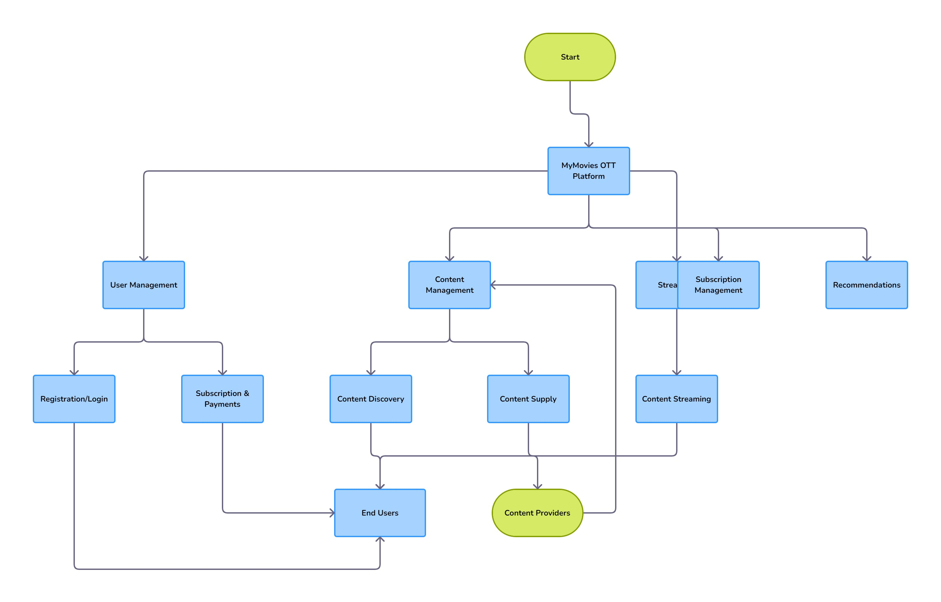

A. Appendices

In the "Appendices" section of the Software Requirements Specification (SRS) for the MyMovies OTT platform, you can include additional information that provides context and insight into the project. Appendices can contain supporting documents such as initial conceptual designs, meeting minutes, and other helpful materials. It's important to specify whether the information in the appendices is considered part of the SRS's overall set of requirements.

A.1 Appendix 1: Initial Conceptual Documents

This appendix may include early project documents such as wireframes, sketches, or flowcharts.

It provides insight into the initial design concepts and thought processes behind the platform's development.

These documents can help track the evolution of the project from its initial stages to its current state.

It may also include use case scenarios that highlight user interactions with the platform.

A.2 Appendix 2: Meeting Minutes with Customers

This appendix includes minutes from meetings with customers or stakeholders.

Meeting minutes may contain discussions on requirements, design decisions, and feature requests.

They can provide valuable context on customer expectations and priorities for the platform.

This information can be useful for verifying the requirements and ensuring alignment with customer needs.

In your SRS, make sure to specify whether the information in the appendices is part of the overall set of requirements. This distinction helps clarify which information is binding and should be taken into account when designing, implementing, and testing the software. Appendices can offer valuable historical context and support for the main content of the SRS, but their role in setting specific requirements should be explicitly stated.

